ifj.kke ctV
OUTCOME BUDGET
2008-09

laLd`fr ea=ky;
MINISTRY OF CULTURE

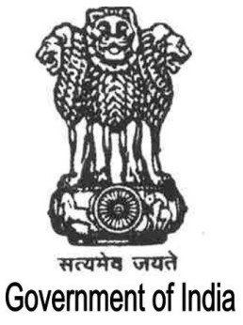
Hkkjr ljdkj
GOVERNMENT OF INDIA
Contents

Page No.

Executive Summary i - iii

Chapter I 1-13

Chapter II 14-149

Chapter III 150-154

Chapter IV-A 155-225

Chapter IV-B 226-385

Chapter V 386-397

Chapter VI 398-410

